MANUAL FOR UPLOADING AND VIEWING DETAILS USING KOBOTOOLBOX SOFTWARE:

WEBSITE FOR KOBOTOOLBOX:

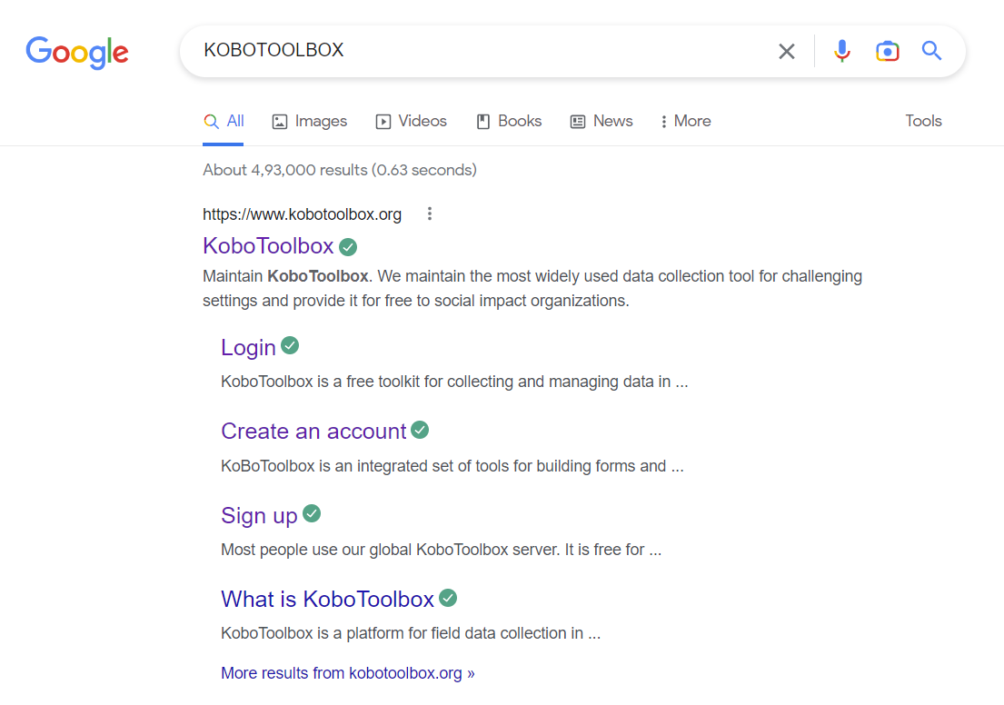

CREATE AN ACCOUNT - CLICK CREATE AN ACCOUNT

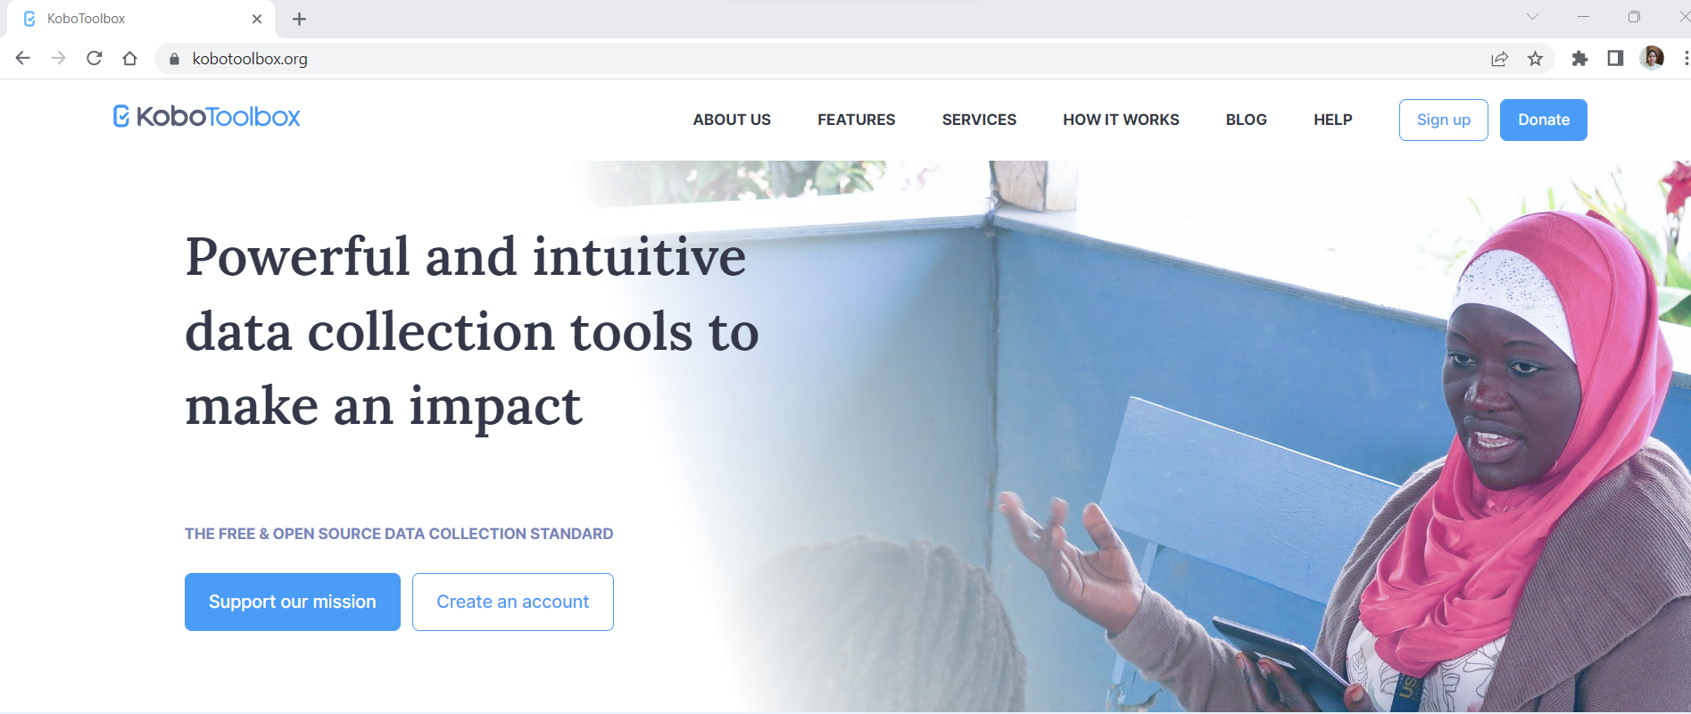

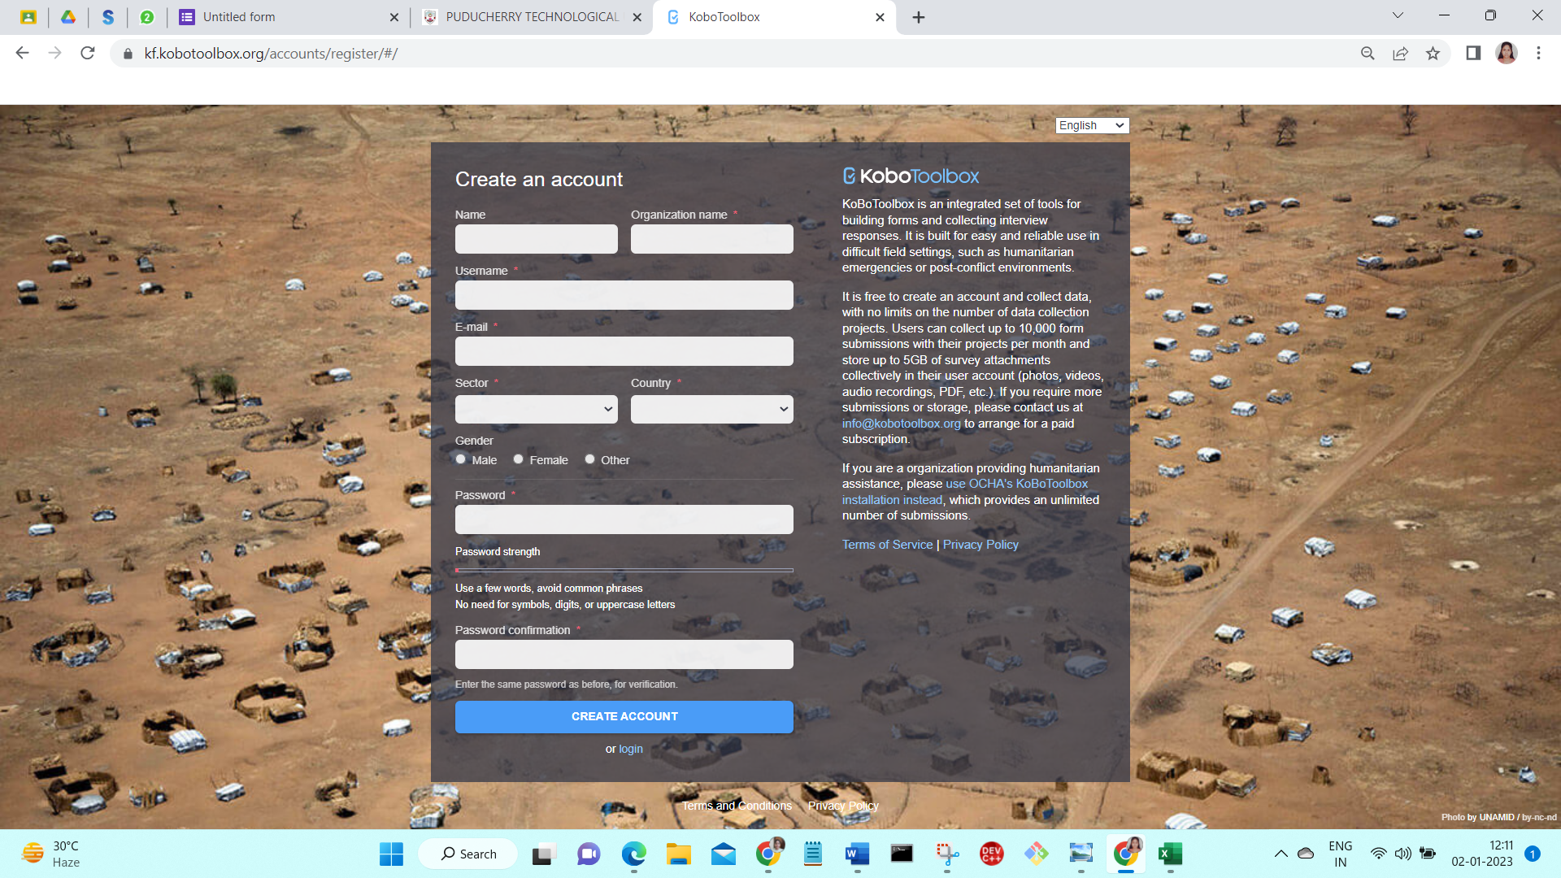

THEN SIGN UP/SIGN IN:

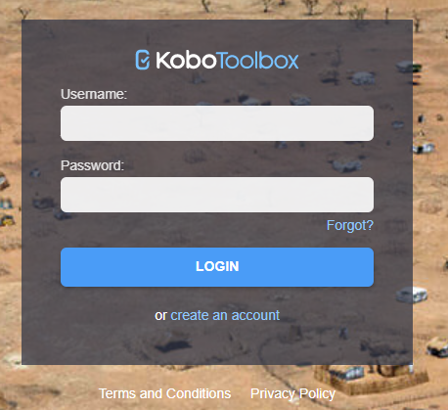

KOBOTOOLBOX INTERFACE:

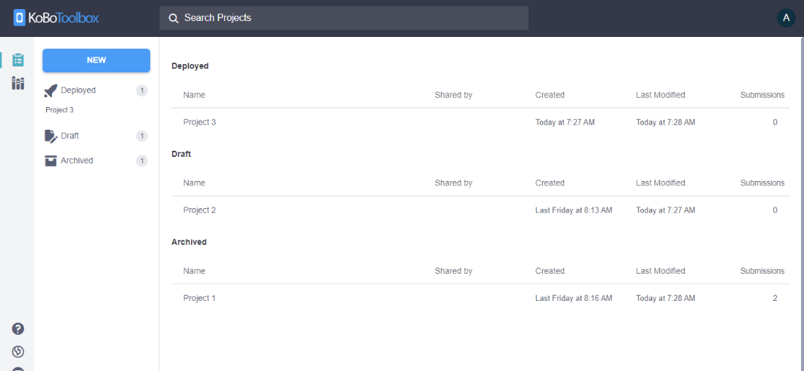

CREATING YOUR FIRST FORM:

click the big blue NEW button at the top. You will be presented with the “Create a project: choose a source” dialog box.

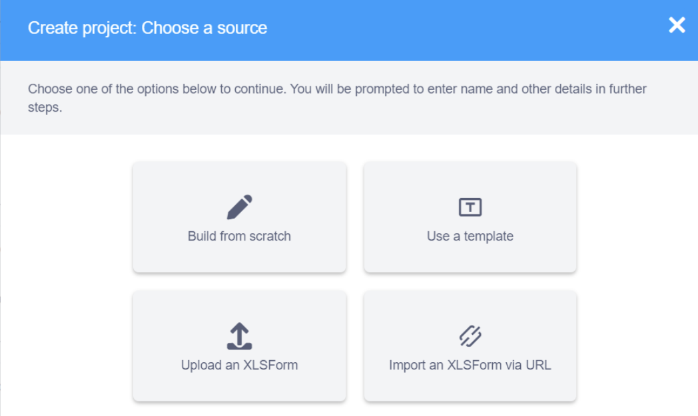

Since the project is already created, choose upload an xls form

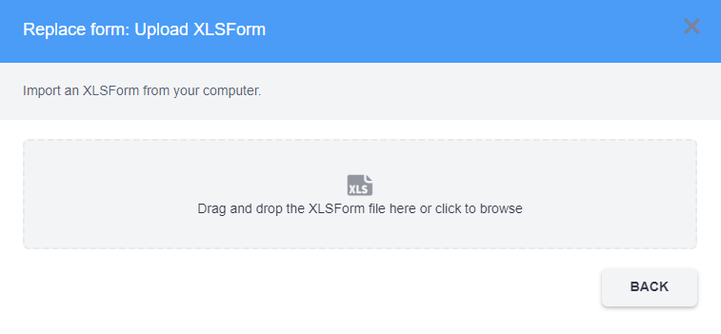



And upload the highlighted xls form from the folder:

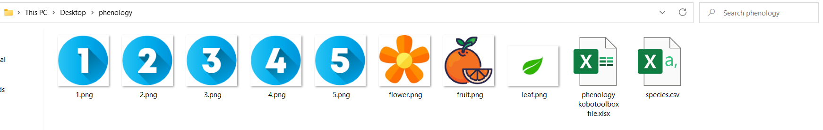



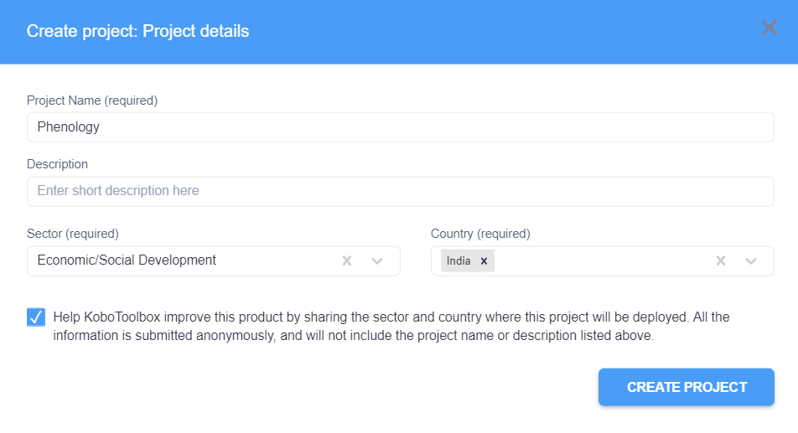

Then the interface looks like this:

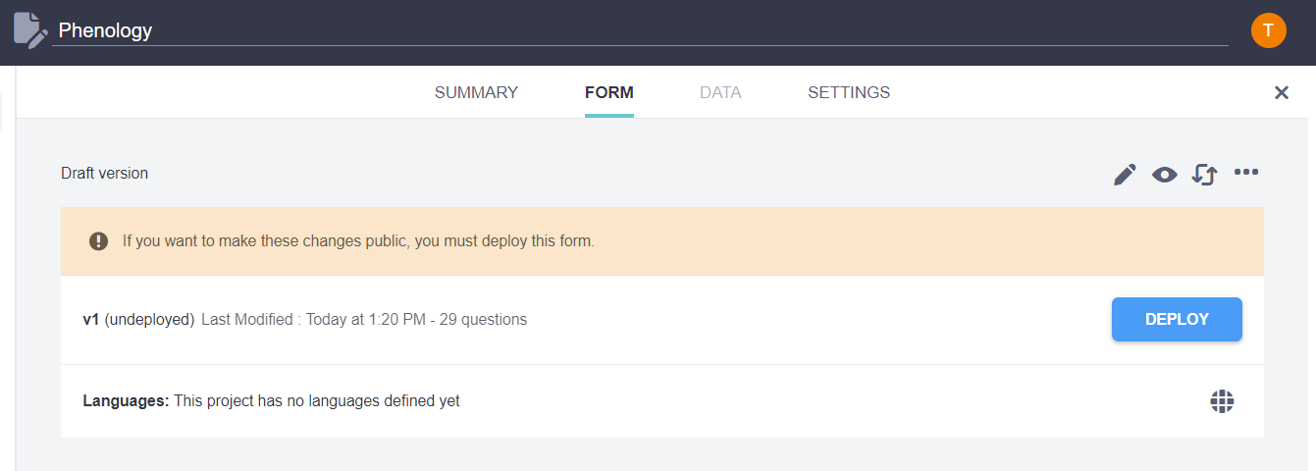

Then click the settings, then click on media and upload the remaining files from the folder:

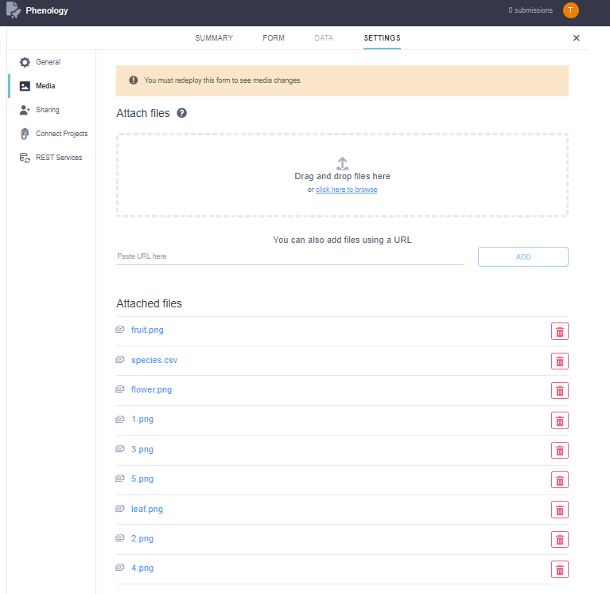

Then deploy the file:

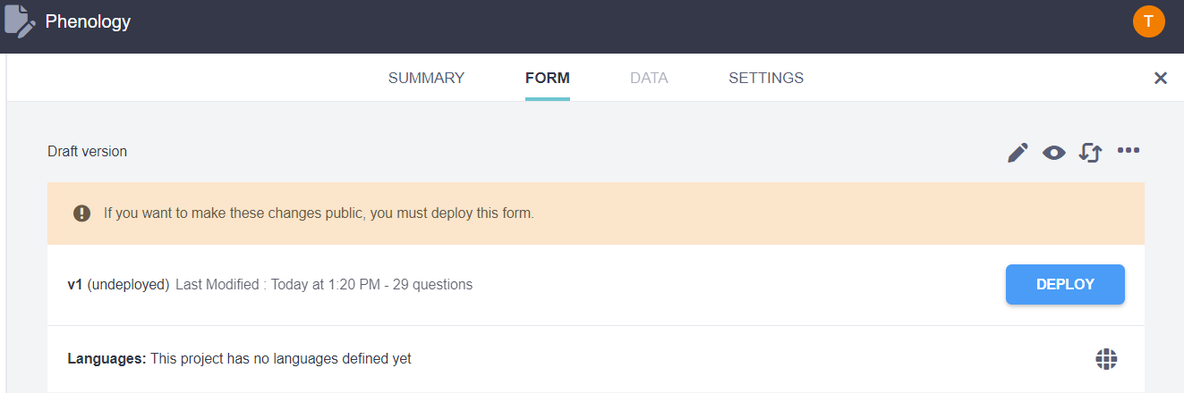

Then it looks like:

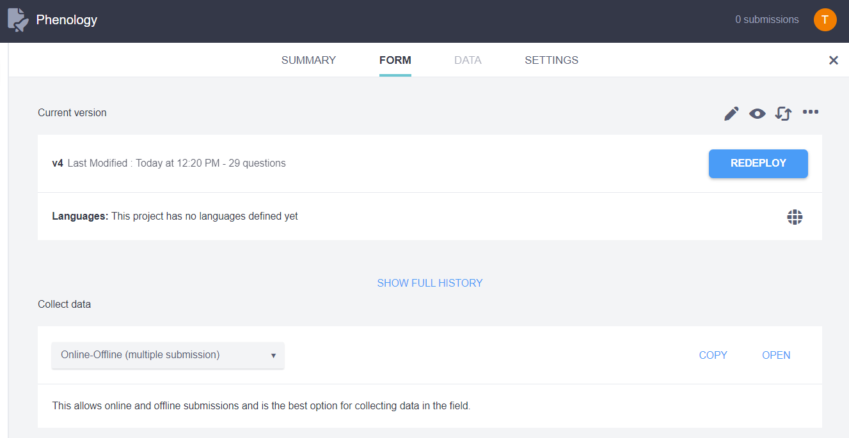

Then to preview the file click the eye button,then u can view the file.

Then to collect data to the form,

# Either in online mode you can collect data by clicking the copy icon, which generates a link and you can share the link to collect data.

#Or you can collect data in offline mode by installing kobocollect app in your phone/tab:

1. Kobo Collect can only be used in phones or tablets using the Android Operating System. It is not available in iPhones and Blackberry phones.  
   Using your phone, go to your Applications and open Play Store. Search for KOBO COLLECT.
2. Install Kobo Collect on your phone.
3. Once installed, open Kobo Collect and look for the General Settings (you need to press the three dots on the side of your screen or press the left button on the bottom of your phone).

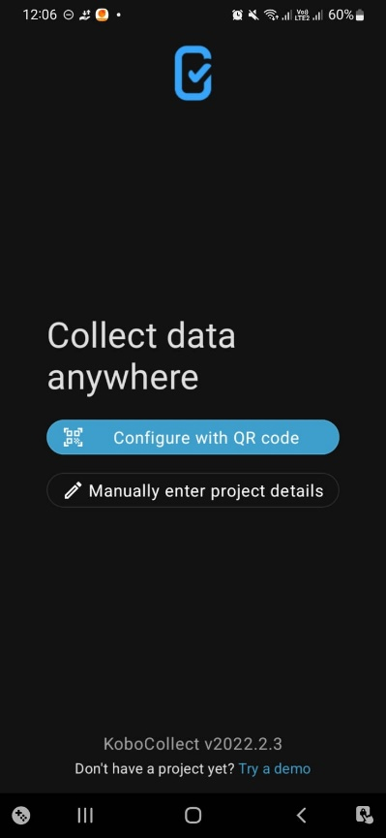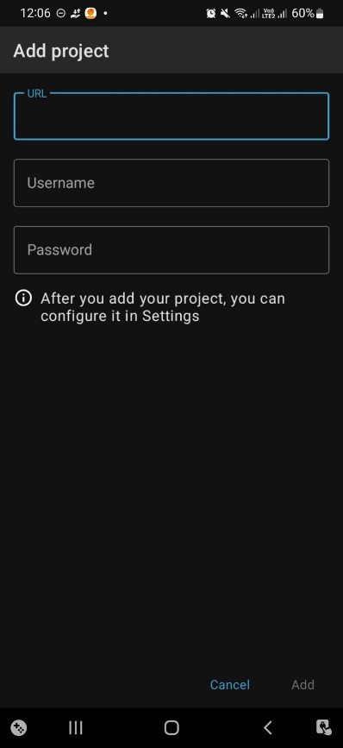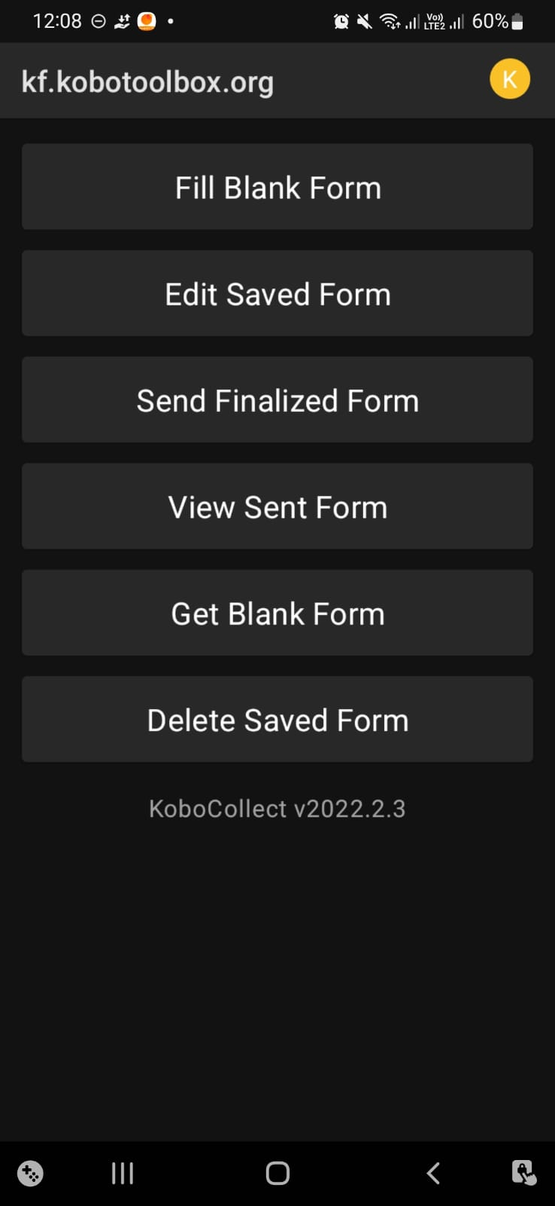

Then choose get blank form ,then the phenology form has to be selected and imported.

Then using fill blank form fill up the details and click submit button.

Then to further edit the form you can choose edit saved form and re-enter the details.

Then through send finalized forms upload the data form to view in your system.

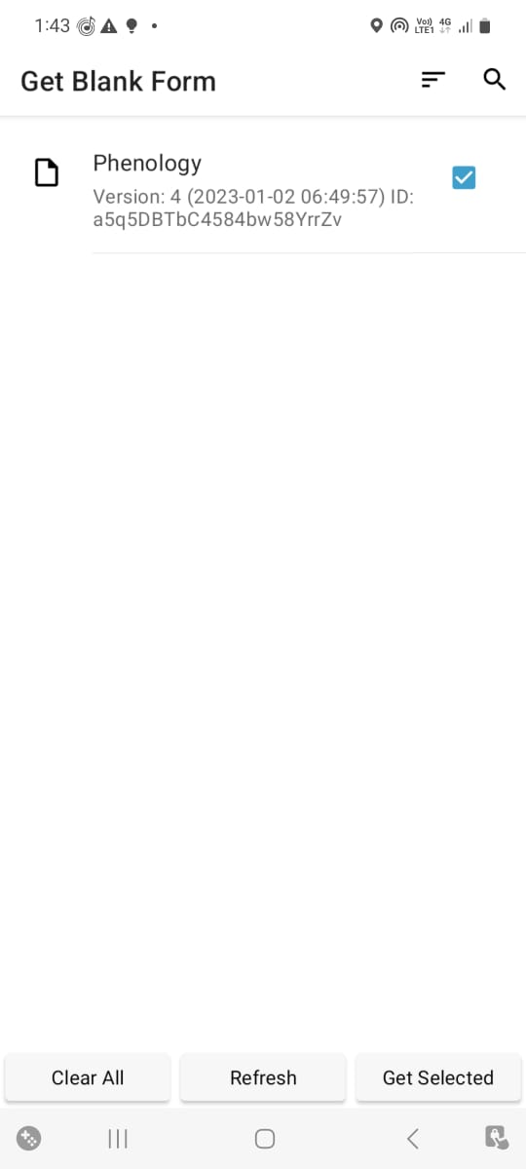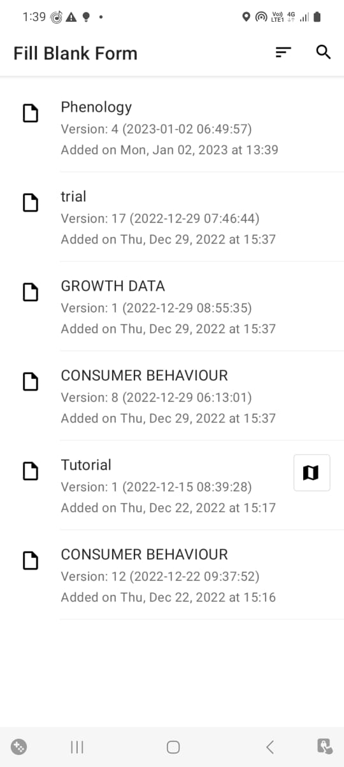

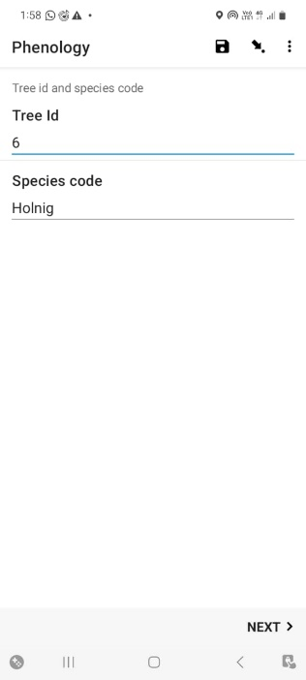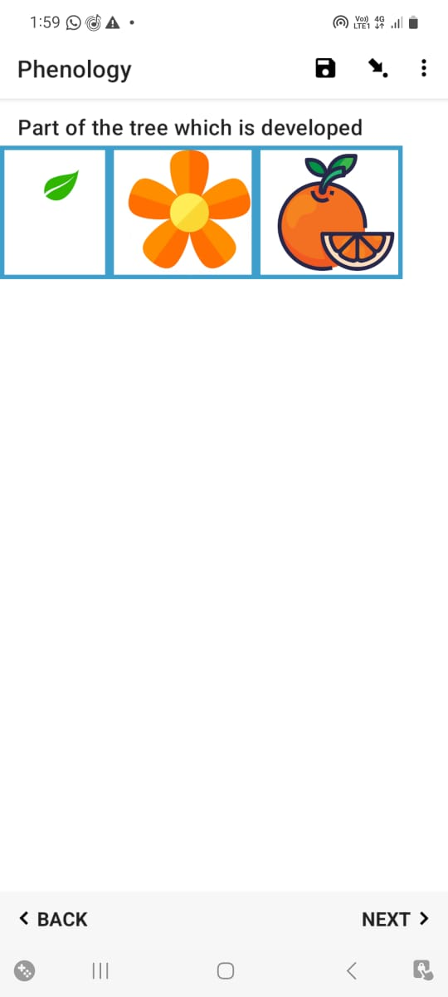

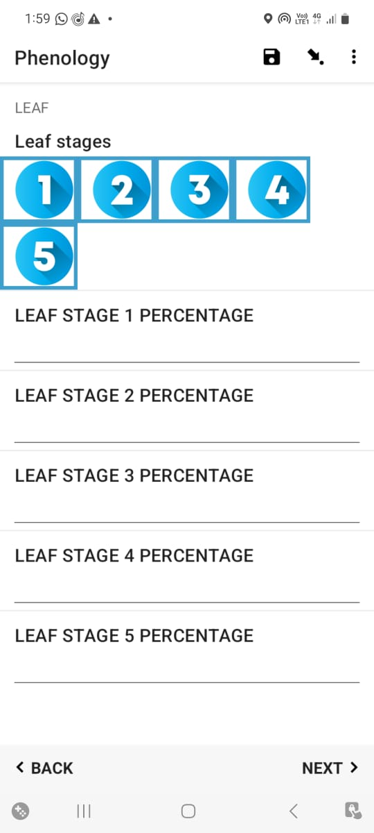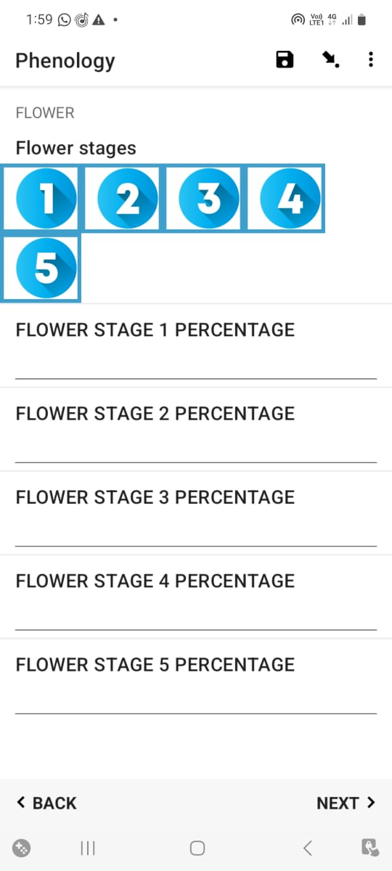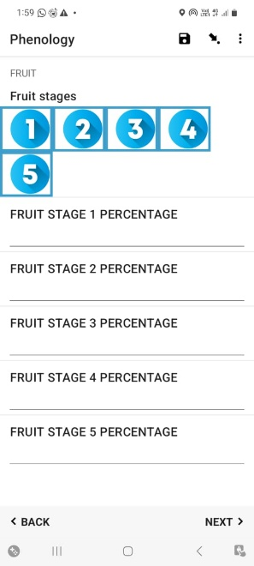

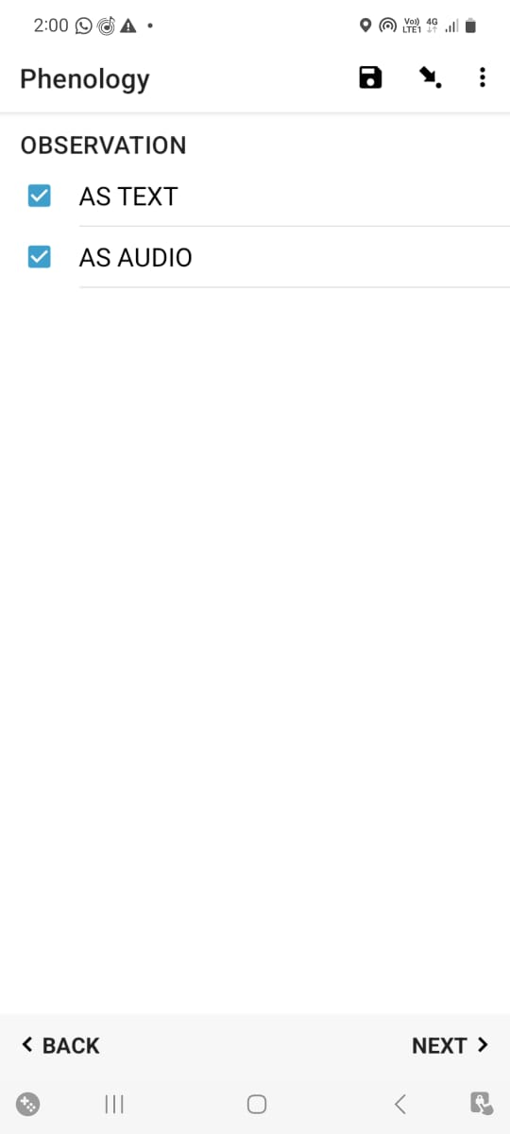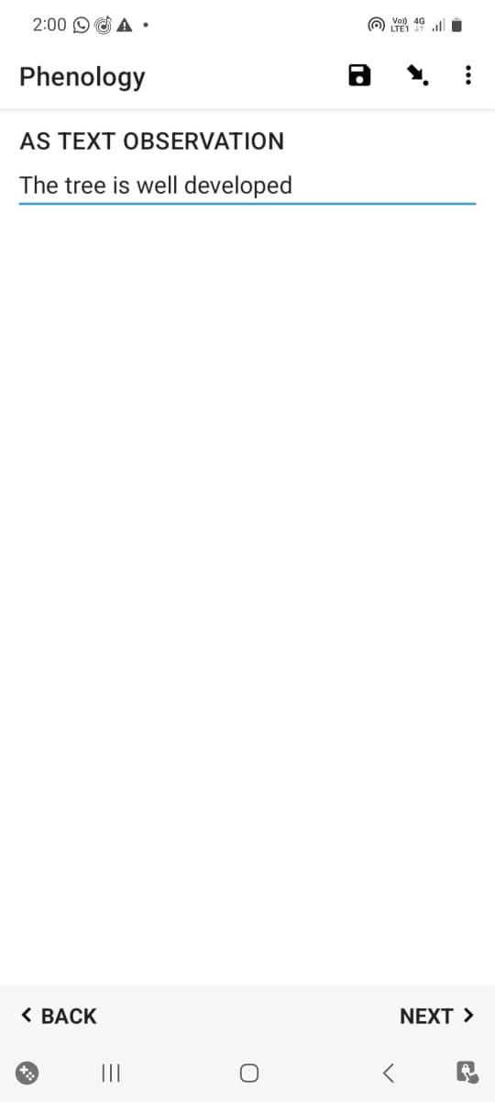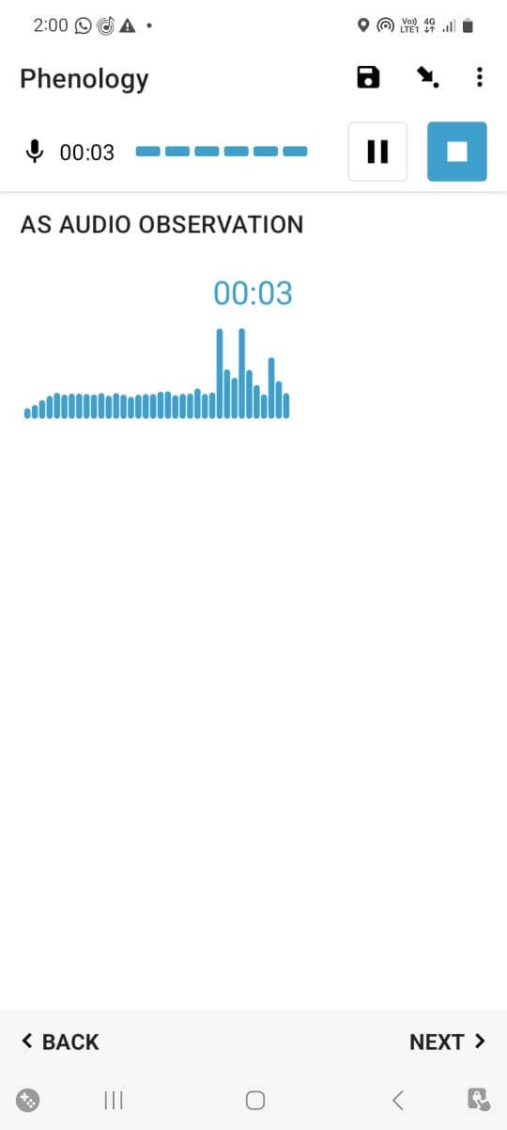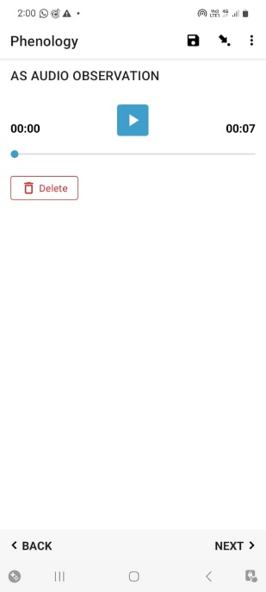

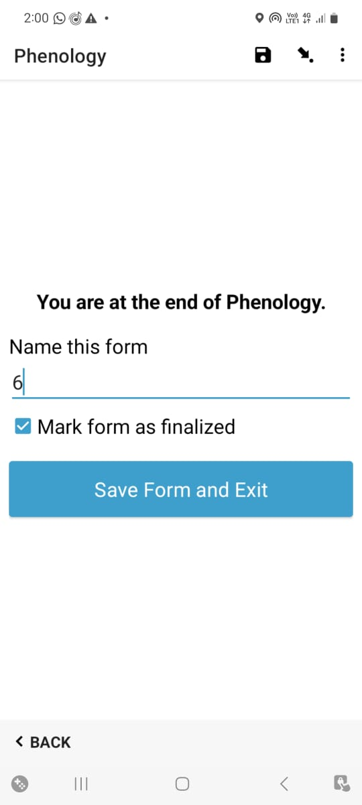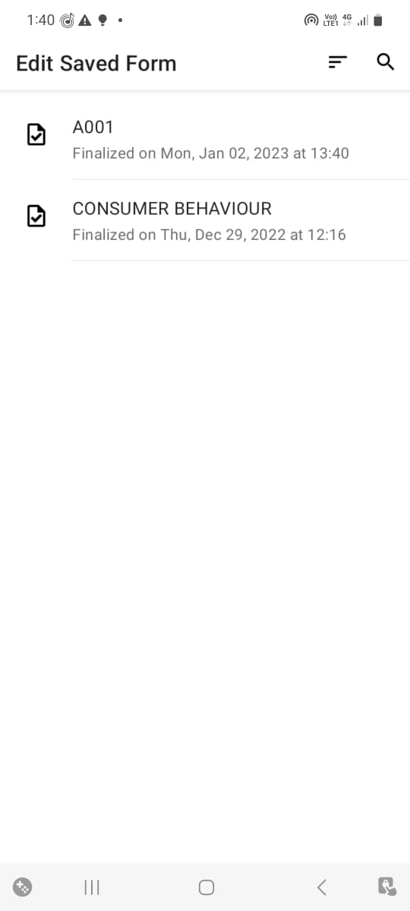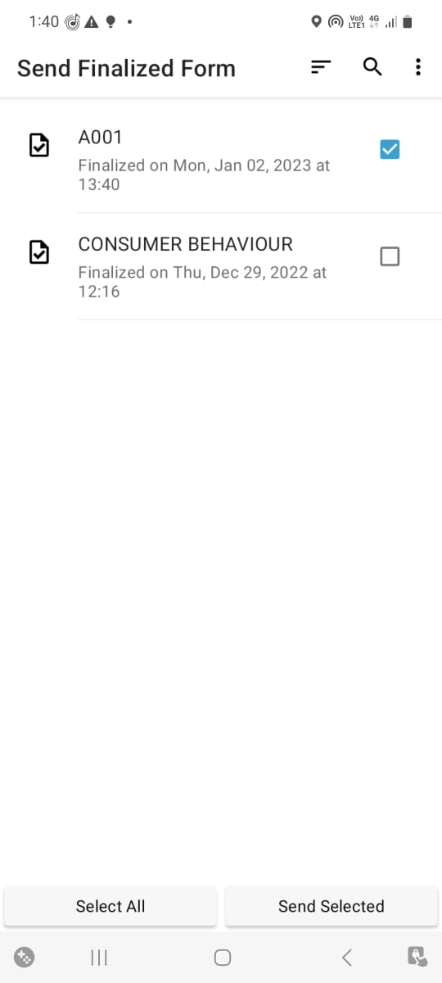

VIEWING THE DATA :

Then the filled forms data can be viewed and download in our system:

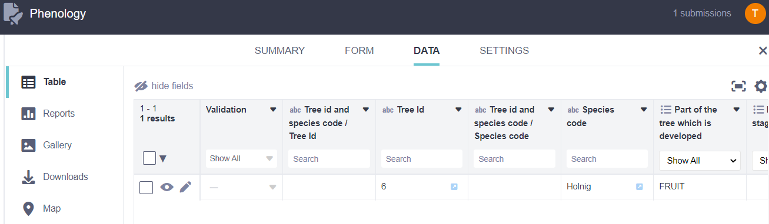

DOWNLOADING THE DATA:

By clicking the export icon the excel data will be downloaded

with all the columns ,and we can delete the unnecessary columns in the excel file and save it form further use.

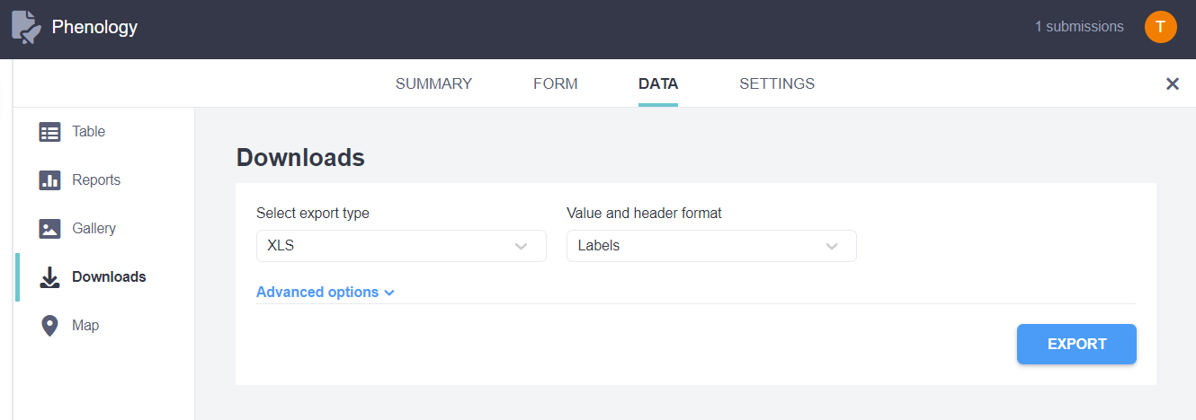

Then for easy use for next year,we can deleted the forms filled in previous year and upload the current year forms or we can download and sort according to today column.